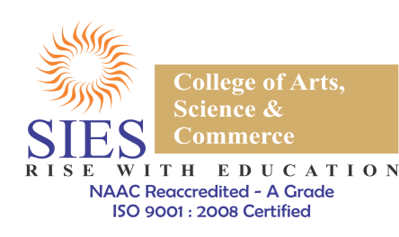
NAME OF EVENT: RECRUTIFY.
DATE: 27TH October, 2018.
START TIME: 10:00am.
END TIME: 12:15pm.

AIM :
The aim of this event was to bring out the entrepreneur within everyone. It was crafted in a manner that every participant would have to expand their thought process and think outside the box.

ABOUT THE EVENT:
The working hands and minds of a firm or a company are the key to its development. Convincing people to give in their efforts for the same, shows its true scope, which is why the event focused on how well you can sell your company to it’s potential employees. It was a team event. The event was divided in two rounds. For the first round, the teams were given a common topic ‘Is the modernized office culture as good for us as we think it is?' on which a group debate was carried out. For the last and final round, the teams spoke about and presented their companies to everyone present there, who were their potential employees. The teams were judged with the help of a voting sheet which was provided to everyone.
The event was carried out by a team of certain members of EDC, with the help and guidance of the BODs. The event was also attended by the Convener of EDC, Prof. Uma Kokku, and Prof. Sarvanan Nadar. The feedbacks received at the end of the event were very pleasing and motivating in every way.

SUMMARY:
The event was a step towards making people Job creators instead of job seekers. It provided them with a boost in their confidence and helped them to know and understand a broader perspective of what their creativity is capable of.

